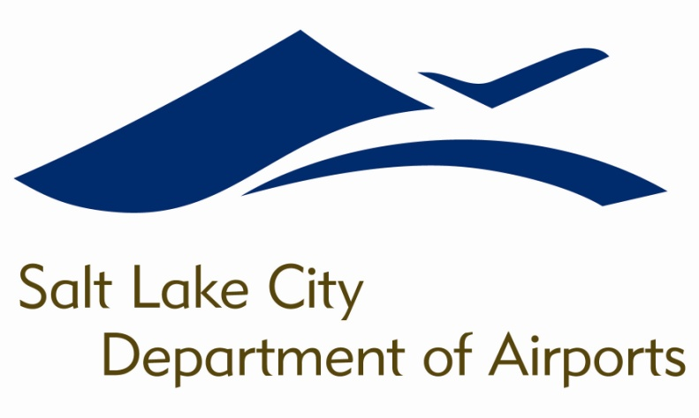

SALT LAKE CITY DEPARTMENT OF AIRPORTS
BOARD MEETING AGENDA

18 April 2018
8:00 A.M.

CONSENT AGENDA

Minutes of the 21 February and 21 March 2018 Meetings

DISCUSSION ITEMS

Director’s Report – Bill Wyatt, Executive Director, SLCDA
- Master Plan Update – Allen McCandless, Planning Director, SLCDA
- Airport Redevelopment Program (ARP) Update – Mike Williams, ARP Director, SLCDA

INFORMATION ITEMS

A. Financial Report – February 2018

B. Air Traffic Statistics – February 2018

C. Comparison of On-Time Operations – January 2018

D. Construction Report – April 2018

E. Media Clippings – April 2018

The next meeting will be held on Wednesday, May 16, 2018, at 8:00 a.m. Meetings are held in the Board Room located on the third level of the short-term parking garage. People with disabilities may make requests for reasonable accommodations no later than 48 hours in advance in order to attend this Airport Board Meeting. Accommodations may include alternate formats, interpreters, and other auxiliary aids. This is an accessible facility. For questions or additional information, please contact LuJean Christensen at 801-575-2096.

