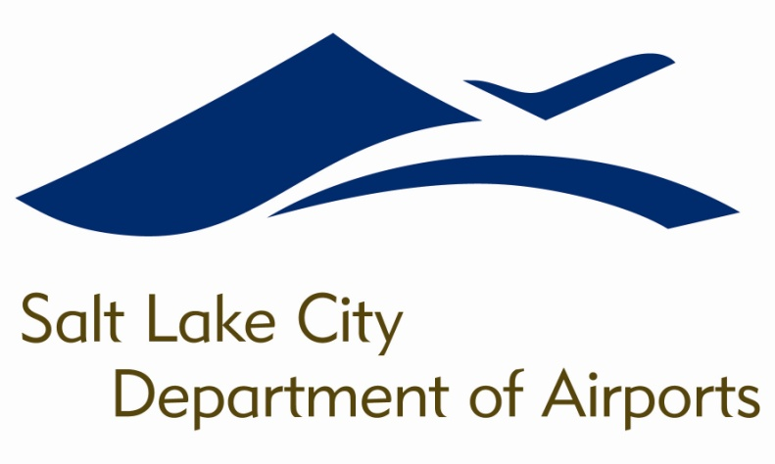

SALT LAKE CITY DEPARTMENT OF AIRPORTS
BOARD MEETING AGENDA

21 March 2018
8:00 A.M.

DISCUSSION ITEMS

Director’s Report – Bill Wyatt, Executive Director, SLCDA
- Airport Redevelopment Program (ARP) Update – Mike Williams, ARP Director, SLCDA
- Airport Budget for FY2019 – Ryan Tesch, Finance Director, SLCDA
- Future 5th Runway – Allen McCandless, Planning Director, SLCDA
- Concessions Program RFP Update – John Buckner, Commercial & Administration Director, SLCDA

INFORMATION ITEMS

A. Financial Report – January 2018

B. Air Traffic Statistics – January 2018

C. Comparison of On-Time Operations – December 2017

D. Construction Report – March 2018

E. Media Clippings – March 2018

The next meeting will be held on Wednesday, April 18, 2018, at 8:00 a.m. Meetings are held in the Board Room located on the third level of the short-term parking garage. People with disabilities may make requests for reasonable accommodations no later than 48 hours in advance in order to attend this Airport Board Meeting. Accommodations may include alternate formats, interpreters, and other auxiliary aids. This is an accessible facility. For questions or additional information, please contact LuJean Christensen at 801-575-2096.

